Dynatrace AppMon Review & Design for



Publication Detail

Prepared by:
PT Mitra Integrasi Informatika
APL Tower, Lt. 37ᵗʰ Suite 1- 8
Jl. Letjen S. Parman Kav. 28
Jakarta 11470

Date: July 27, 2018 Version: 1.3

Document version
Version | Date | Author | Remarks
1.0 | June 05, 2018 | Miftah Reza Maulana | Intial Document
1.1 | June 06, 2018 | Miftah Reza Maulana | - Edited “Dynatrace Deployment Component”  - Added “Agent Overview”  - Edited “Existing” & “Planned”
1.2 | July 18, 2018 | Miftah Reza Maulana | - Major Update
1.3 | July 27, 2018 | Miftah Reza Maulana | - Minor Update

Document authorization
PT. Mitra Integrasi Informatika |  | PT. Manulife Indonesia |  | PT. Manulife Indonesia
Rahmat Julizar |  | Wayan Budiastika |  | Adi Wijaya Sutanto
Date: |  | Date: |  | Date:

Table of Contents
Publication Detail 0
Document version 1
Document authorization 1
1. Introduction 3
2. Architecture Overview 3
2.1. Dynatrace Deployment Component 4
2.1.1 Production Environment 4
3. Dynatrace AppMon Server 4
3.1. Sizing 4
3.1.1 Production Environment 4
3.2. Installation Path 5
3.2.1 Production Environment 5
3.3. Ports 5
3.3.1 Production Environment 5
4. Custom Configuration 6
4.1 System Profile 6
4.2 Custom Dashboards 6
4.3 Synthetic Monitoring 6
5. Technology Overview 7
6. Agent Overview 7
7. Attachment (Optional) 9

Introduction
The following document describes the high-level Dynatrace AppMon deployment design for the PT. Manulife Indonesia monitoring environment. The application in scope are IIS Web Server and .NET Application, and the initial deployment will include a total of 11 IIS Web Server Agent and 3 .NET Application Agent in Production. No additional license for SIT or UAT.

This document outlines the architecture details and sizing recommendations for the Dynatrace AppMon, as well as details and recommendations on optional another Dynatrace AppMon components to be considered.

Architecture Overview
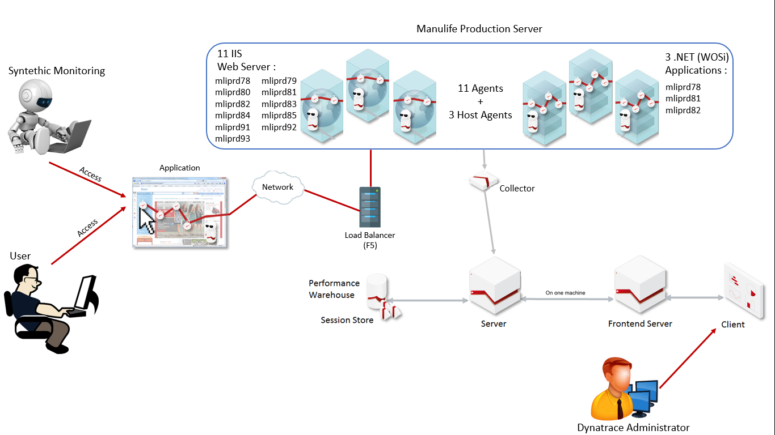

2.1. Dynatrace Deployment Component

Production Environment
The table below is describe PT. Manulife Indonesia Dynatrace AppMon in Production and applied different condition with the new version of Dynatrace AppMon that will be installed later.
Component | As-Is | To-Be
- Dynatrace Appmon Server
- Dynatrace AppMon Server | Installed v.6.2 on 10.244.33.17 (mlibpmlt02.mlijkt01.manulife.com) | Will be installed v.7.0 on same machine
- Dynatrace Collector
- Dynatrace Collector | Installed v.6.2 on 10.244.33.20 (mlibpmlt01.mlijkt01.manulife.com) | Will be installed v.7.0 on same machine
- Dynatrace Frontend Server
- Dynatrace Frontend Server | Installed v.6.2 on 10.244.33.17 (mlibpmlt02.mlijkt01.manulife.com) | Will be installed v.7.0 on same machine
- Dynatrace AppMon Agent
- IIS Agent | Installed 23 Agent in different machine | Will be installed 11 Agent as User Request
- .NET Agent | Installed 15 Agent in different machine | Will be installed 3 Host Agent as User Request
Total Agent | 38 Agents | 11 Agents + 3 Host Agent
For more details about AppMon Agents, see Agent Overview

Dynatrace AppMon Server

3.1. Sizing

Production Environment
The table below is describe PT. Manulife Indonesia Dynatrace AppMon Hardware Sizing in Production and applied the same condition as new version of Dynatrace AppMon that will be installed later.
As-Is & To-Be
Component | Operating System | CPU | Memory | Storage
Dynatrace AppMon Server (type “Medium”) | Windows Server 2008 R2 SP1 | 8 Core | 32 GB | 160 GB
Dynatrace AppMon Frontend Server
Dynatrace Collector | Windows Server 2008 R2 SP1 | 4 Core | 12 GB | 160 GB
Dynatrace AppMon Agent | - | - | - | -

3.2. Installation Path

Production Environment
The table below is describe PT. Manulife Indonesia Dynatrace AppMon Installation Directory in Production and applied the same condition as new version of Dynatrace AppMon that will be installed later.
Directory Symbol | As-Is | To-Be
- Dynatrace AppMon Server
- Dyantrace Server Directory | D:/Program Files/dynaTrace/dynaTrace 6.2/server/ | D:/Program Files...
- Dynatrace Frontend Server Directory | D:/Program Files/dynaTrace/dynaTrace 6.2/server/ | D:/Program Files...
- Dynarace AppMon Collector
- Dynatrace Collector Directory | D:/Program Files/dynaTrace/dynaTrace 6.2/collector/ | D:/Program Files...
- Dynarace AppMon Agent
- Dynatrace Agent Directory | D:/Program Files/dynaTrace/dynaTrace 6.2/agent/ | D:/Program Files...

3.3. Ports

Production Environment
The table below is describe PT. Manulife Indonesia Required Ports (Dynatrace AppMon) in Production and applied the same condition as new version of Dynatrace AppMon that will be installed later.
As-Is & To-Be
Port | Used by | Protocol
2021 | Client -> Frontend Server | TCP
8023 | Client -> Frontend Server | HTTP
2031 | Frontend Server -> Server | TCP
6698, 6699 | Collector -> Server | TCP
8033 | Collector -> Server | HTTP
8040, 8041 | Collector -> Server | HTTP(S)
9998 | Agent -> Collector | TCP
8042, 8043 | Agent -> Collector | HTTP(S)
7788 | Memory Analysis Server -> Server | TCP
8020, 8021 | Browser -> Server | HTTP(S)
9911 | AppMon Web -> Frontend Server | HTTPS
8001 | Slave Web Server Agent -> Master Agent Web Server Agent | UDP

Custom Configuration

4.1 System Profile
The table below is describe PT. Manulife Indonesia System Profile (Dynatrace AppMon) in Production and applied the same condition as new version of Dynatrace AppMon that will be installed later.
System Profile Name | As-Is  (Enabled ?) | To-Be
Monitoring | ✔ | Used
AgencyLinkProd | ✔ | Not Used
CustomerWebsite | ✔ | Not Used
eSolution | ✔ | Not Used
PartnerLinkProd | ✔ | Not Used
GoSpace | ✖ | Not Used

4.2 Custom Dashboards
The table below is describe PT. Manulife Indonesia Custom Dashboards (Dynatrace AppMon) in Production and applied the same condition as new version of Dynatrace AppMon that will be installed later.
Number of Dashboard
As-Is | To-Be
48 Custom Dashboards | - Dashboard per Application  - Dashboard per Infrastructure  - Dashboard per Technology (Custom Dashboard)

4.3 Synthetic Monitoring
The table below is describe PT. Manulife Indonesia Synthetic Monitoring (Dynatrace AppMon) status in Production and applied different condition with the new version of Dynatrace AppMon that will be installed later.
Synthetic Monitoring
As-Is  (Enabled ?) | To-Be  (Enabled ?)
✖ | ✔  Max 20 Syntethic Scripts

Technology Overview
The table below is describe PT. Manulife Indonesia Technology Overview (Dynatrace AppMon) in Production and applied different condition with the new version of Dynatrace AppMon that will be installed later.
Technology Name | Number of Agent
Technology Name | As-Is | To-Be
IIS Web Server | 23 | 11
.NET Application | 15 | 3
Total Agent | 38 Agents | 11 Agents + 3 Host Agent

Agent Overview
The table below is describe PT. Manulife Indonesia Synthetic Monitoring (Dynatrace AppMon) status in Production and applied different condition with the new version of Dynatrace AppMon that will be installed later.
As-Is
Host | Agent Name | Agent Type | System Profile
10.244.30.14  (Mliprd75) | mliprd75 | IIS | Monitoring
10.244.200.11  (Mliprd78) | Parner_WEB | IIS | PartnerLinkProd
10.244.200.11  (Mliprd78) | Prod_WEB | IIS | AgencyLinkProd
10.244.200.11  (Mliprd78) | cwsmdadpkpool | .NET | CustomerWebsite
10.244.200.11  (Mliprd78) | Prod_Services | .NET | AgencyLinkProd
10.244.200.11  (Mliprd78) | cwsmdadpkpool_cwsmdagspool | .NET | CustomerWebsite
10.244.200.11  (Mliprd78) | Prod_WCF_AWSHOME | .NET | AgencyLinkProd
10.244.200.11  (Mliprd78) | Prod_WCF_AWSWCF | .NET | AgencyLinkProd
10.244.200.11  (Mliprd78) | Prod_WCF_WEB | .NET | AgencyLinkProd
10.244.200.12  (Mliprd79) | awswcfpool | .NET | Monitoring
10.244.200.12  (Mliprd79) | awswebpool | .NET | Monitoring
10.244.200.12  (Mliprd79) | Parner_WEB | IIS | PartnerLinkProd
10.244.200.12  (Mliprd79) | Prod_WEB | IIS | AgencyLinkProd
10.244.200.13  (Mliprd80) | awswebpool | .NET | Monitoring
10.244.200.13  (Mliprd80) | Parner_WEB | IIS | PartnerLinkProd
10.244.200.13  (Mliprd80) | Prod_WEB | IIS | AgencyLinkProd
10.244.200.14  (Mliprd81) | Parner_WEB | IIS | PartnerLinkProd
10.244.200.14  (Mliprd81) | Prod_WEB | IIS | AgencyLinkProd
10.244.200.15  (Mliprd82) | awswebpool | .NET | Monitoring
10.244.200.15  (Mliprd82) | Parner_WEB | IIS | PartnerLinkProd
10.244.200.15  (Mliprd82) | Prod_WEB | IIS | AgencyLinkProd
10.244.200.16  (Mliprd83) | Parner_WEB | IIS | PartnerLinkProd
10.244.200.16  (Mliprd83) | Prod_WEB | IIS | AgencyLinkProd
10.244.200.17  (Mliprd84) | Parner_WEB | IIS | PartnerLinkProd
10.244.200.17  (Mliprd84) | Prod_WEB | IIS | AgencyLinkProd
10.244.200.18  (Mliprd85) | awswcfpool | .NET | Monitoring
10.244.200.18  (Mliprd85) | awswebpool | .NET | Monitoring
10.244.200.18  (Mliprd85) | Parner_WEB | IIS | PartnerLinkProd
10.244.200.18  (Mliprd85) | Prod_WEB | IIS | AgencyLinkProd
10.244.200.20  (Mliprd91) | Parner_WEB | IIS | PartnerLinkProd
10.244.200.20  (Mliprd91) | Prod_WEB | IIS | AgencyLinkProd
10.244.200.22  (Mliprd92) | awswebpool | .NET | Monitoring
10.244.200.22  (Mliprd92) | Parner_WEB | IIS | PartnerLinkProd
10.244.200.22  (Mliprd92) | Prod_WEB | IIS | AgencyLinkProd
10.244.200.21  (Mliprd93) | awswebpool | .NET | Monitoring
10.244.200.21  (Mliprd93) | cwserinfopool | .NET | Monitoring
10.244.200.21  (Mliprd93) | Parner_WEB | IIS | PartnerLinkProd
10.244.200.21  (Mliprd93) | Prod_WEB | IIS | AgencyLinkProd
To-Be
Host | Agent Name | Agent Type | System Profile
10.244.200.11  (Mliprd78) | awswcfpool | .NET | Monitoring
10.244.200.11  (Mliprd78) | awswebpool | .NET | Monitoring
10.244.200.11  (Mliprd78) | bwswcfpool | .NET | Monitoring
10.244.200.11  (Mliprd78) | bwswebpool | .NET | Monitoring
10.244.200.11  (Mliprd78) | ProdIISServer | IIS | Monitoring
10.244.200.12  (Mliprd79) | ProdIISServer | IIS | Monitoring
10.244.200.13  (Mliprd80) | ProdIISServer | IIS | Monitoring
10.244.200.14  (Mliprd81) | awswcfpool | .NET | Monitoring
10.244.200.14  (Mliprd81) | awswebpool | .NET | Monitoring
10.244.200.14  (Mliprd81) | bwswcfpool | .NET | Monitoring
10.244.200.14  (Mliprd81) | bwswebpool | .NET | Monitoring
10.244.200.14  (Mliprd81) | ProdIISServer | IIS | Monitoring
10.244.200.15  (Mliprd82) | awswcfpool | .NET | Monitoring
10.244.200.15  (Mliprd82) | awswebpool | .NET | Monitoring
10.244.200.15  (Mliprd82) | bwswcfpool | .NET | Monitoring
10.244.200.15  (Mliprd82) | bwswebpool | .NET | Monitoring
10.244.200.15  (Mliprd82) | ProdIISServer | IIS | Monitoring
10.244.200.16  (Mliprd83) | ProdIISServer | IIS | Monitoring
10.244.200.17  (Mliprd84) | ProdIISServer | IIS | Monitoring
10.244.200.18  (Mliprd85) | ProdIISServer | IIS | Monitoring
10.244.200.20  (Mliprd91) | ProdIISServer | IIS | Monitoring
10.244.200.22  (Mliprd92) | ProdIISServer | IIS | Monitoring
10.244.200.21  (Mliprd93) | ProdIISServer | IIS | Monitoring

Attachment (Optional)
The list of picture below are show Old Dynatrace AppMon of PT. Manulife Indonesia for existing configuration.
